Software Development Life Cycle

IT Project Management



The PMO Concept

Author: Yaacov (Jack) Bar-Tor

Version 1.0

Date: 29 July 2026

UUUDocument Change Control

Changes

Ver | Date | Author | Summary of Changes
1.0 | 29 July 2026 | Yaacov (Jack) Bar-Tor | First Release to Customer

Approvals

Designation | Name | Signature | Date

UUUTable of Contents

1 Executive Summary 1
1.1 What is Project Management 1
1.2 Elements of Project Management 1
1.3 The Need for the PMO 2
1.4 What can a PMO Do? 3
1.5 It’s Hard to Measure Success 4
1.6 The Lines of Authority 4
1.7 The Strategic Project Office 5
1.8 What is PMMM 6
1.9 Ten Steps to a Successful SPO Launch 6
1.10 PMO Capabilities 6
1.11 Improving Organisational Performance 7
2 PM Assessment & Improvement Planning 8
2.1 Stage 1 – Project Maturity Assessment 8
2.2 Stage 2 – The Improvement Plan 8
Attachments 9
Attachment A - Project Management Maturity Model 9
End Of Document 10

Figures
Figure 1: The Project Management Elements 1
Figure 2: The Ten Steps of a Successful Strategic Project Office Launch 6

Executive Summary

What is Project Management
Ambiguity is perhaps one of the greatest causes of failure of projects. Ambiguity causes scope creep, missed deadlines, run-away costs, under/over utilization of resources, and others. The Project Manager’s job is to identify and eliminate ambiguities; otherwise the project planning is nothing more guesswork.
Let's first look at what is and what is not a project. We'll use the definition of project from the Project Management Institute, which is:
A project is a temporary endeavour undertaken to create a unique product or service.
A project is considered temporary since once the projects objectives are met, the project team will break-up and go onto other projects. The goal of a project is to create something new, or unique.

Elements of Project Management
All projects have three basic elements: tasks, resources and time. These are interrelated and any change in one has an effect on the other two. This is illustrated below:
Figure 1: The Project Management Elements
Tasks as individual pieces of work which need to be done. Some typical tasks may include:
- Reports to management;
- Pieces of code for an application;
- Project definition documents, and
- Any small (or large) item that contributes to reaching the state goal of the project.
Resources are anything used to meet the stated goals of the project:
- People
- Machinery
- Money
Time typically starts with an estimate (also know as a guess) on how long it may take to reach the stated goal of the project. As the project progresses, the time estimate becomes more solid as each piece of the project is examined and a more firm estimate as to how long it'll take to produce the individual pieces.
These three pieces are interrelated. If one thinks of the three as a triangle, in order for the triangle to remain balanced, any change on one side required changes on the other two. For example, if a new task is added to the project, the Project Manager needs a resources to work on this new task, and the new task may (or may not) affect the time side of the triangle.
Although the concept appears to be simple, its implementation is not. Based on Gartner’s Group publication (2002-2003) 97% - 98% of IT projects, world-wide, are not delivered On Time and / or At Cost and / or To Specifications.

The Need for the PMO
For years, IT departments have struggled to deliver projects on time and within budget. But with today's emphasis on getting more bang for the buck, IT has to rein in projects more closely than ever. That challenge has led many to turn to Project Management Offices (PMOs) as a way to boost IT efficiency, cut costs, and improve on project delivery in terms of time and budget.
While not a new solution, the trend toward implementing PMOs to install much-needed project management discipline in IT departments is spreading fast. "More people lately have been talking to me about PMOs than they have in the last 10 years," says Don Christian, a partner at PricewaterhouseCoopers. PMOs can help CIOs by providing the structure needed to standardize project management practices and facilitate IT project portfolio management, as well as determine methodologies for repeatable processes. The Sarbanes-Oxley Act—which requires companies to disclose investments, such as large projects, that may affect a company's operating performance—is also a driver, since it forces companies to keep closer watch on project expenses and progress. W.W. Grainger, an industrial products distributor, has a PMO that "enables us to complete more projects on time and on budget with fewer resources," says Tim Ferrarell, senior vice president of enterprise systems.
But PMOs are no panacea for project challenges, including battling today's tepid business climate. For one thing, there is no uniform recipe for success—it's important that the PMO structure closely hews to a company's corporate culture. PMOs also won't give organizations a quick fix or deliver immediate, quantifiable savings. And companies with PMOs report that they don't necessarily yield easy to use cost-saving benchmarks and performance metrics. In a survey conducted by CIO and the Project Management Institute (PMI), 74 percent of respondents said that lower cost was not a benefit of their PMOs.
However, survey respondents still reported positive benefits from the formation of a PMO, even if quantifiable ROI is elusive.
Out of 450 people surveyed, 303, or 67 percent, said their companies have a PMO. Of those with a PMO, half said the PMO has improved project success rates, while 22 percent didn't know or don't track that metric, and 16 percent said success rates stayed the same. There is also a strong link between the length of time a PMO has been operating and project success rates: The longer the better. While 37 percent of those who have had a PMO for less than one year reported increased success rates, those with a PMO operating for more than four years reported a 65 percent success rate increase. The top two reasons for establishing a PMO, according to the survey: improving project success rates and implementing standard practices. In a finding that indicates PMOs' importance, a survey-leading 39 percent of respondents said the PMO is a strategic entity employed at the corporate level, meaning it sets project standards across the enterprise and is supported by upper managers.
There are two basic models of PMOs: one that acts in a consulting capacity, providing project managers in business units with training, guidance and best practices; and a centralized version, with project managers on staff who are loaned out to business units to work on projects. How a PMO is organized and staffed depends on a myriad of organizational factors, including targeted goals, traditional strengths and cultural imperatives. When deployed in line with an organization's culture, PMOs will help CIOs deliver strategic IT projects that satisfy both the CFO and internal customers. Over time—and CIOs should allow three years to derive benefits—PMOs can save organizations money by enabling better resource management, reducing project failures and supporting those projects that offer the biggest payback.

What can a PMO Do?
At transportation company Schneider National, a PMO provides the foundation for eventually doing portfolio management, according to Mark Mullins, vice president of finance for IT. And at Oregon Health & Science University (OHSU), CIO John Kenagy launched a PMO to help his 350-member IT department improve its project management acumen. "Doing a large project takes a village of people, and we don't want to approach each project as if starting from scratch," Kenagy says.
But while PMOs vary in terms of size, structure and responsibilities, Curtis Cook, president and CEO of consulting company Novations Project Management in Atlanta, says CIOs can expect PMOs to function in the following seven areas.
- Project support: Provide project management guidance to project managers in business units;
- Project management process/methodology: Develop and implement a consistent and standardized process;
- Training: Conduct training programs or collect requirements for an outside company;
- Home for project managers: Maintain a centralized office from which project managers are loaned out to work on projects;
- Internal consulting and mentoring: Advise employees about best practices;
- Project management software tools: Select and maintain project management tools for use by employees, and
- Portfolio management: Establish a staff of program managers who can manage multiple projects that are related, such as infrastructure technologies, desktop applications and so on, and allocate resources accordingly.
Notice that Cook doesn't mention cost savings. While companies entertain a variety of factors for starting a PMO, most proponents agree that cutting IT costs or reducing the number of projects by a set amount should not be among them. PMOs can certainly lead to reduced expenses and fewer projects, but the first motive for creating a PMO is to deliver strategic IT projects with more consistency and efficiency. At Sun Life Financial's American subsidiary, CIO Jim Smith says his company's PMO was launched five years ago primarily "to implement the kind of discipline and project management processes required by the Y2K crisis." The PMO relies on three metrics to determine its effectiveness: accuracy of cost estimates, accuracy of schedule estimates and project stakeholder satisfaction. By all measures, it is a success; from 2001 to 2002, those metrics improved 25 percent, 31 percent and 9 percent, respectively.
Darrel Raynor, managing director at project management company Data Analysis & Results, says PMOs that take on responsibility for resource allocation can improve employee productivity. "By having oversight to all projects and personnel, a PMO can assign the best people to priority projects and keep their attention focused on that project," he says.
Multitasking on several IT projects doesn't work, Raynor says, adding that productivity drops every time an employee switches from one task to another. By eliminating multiple assignments, PMOs can boost productivity while ensuring that priority projects get the most attention. That's the case at Grainger. "We have about 400 people in a centralized IT department, and one of the key benefits is that we're allocating the majority of our resources to the highest priority projects," says Ferrarell.
PMOs can nevertheless deliver a return in three to six months by providing the visibility needed to cancel, postpone, or scale back unnecessary or less strategic projects, says Raynor. At diversified technology services company Schlumberger, Project Office Manager Vincent de Montmollin says the PMO saved more than $3 million by reducing the number of small projects from 233 to 13.

It’s Hard to Measure Success
But Schlumberger's results aren't typical. For survey respondents, improving project success rates is a top goal, yet getting metrics that prove that PMOs are working takes time. In the CIO/PMI survey, 42 percent of companies with PMOs less than 1 year old didn't know or do not track success rates. Only 22 percent of companies with PMOs older than five years said the same. It's inherently difficult to pinpoint project success rates for PMOs less than 3 years old simply because there's no track record of completed projects. Even if CIOs can determine cost savings or success rates, benchmarking results against other organizations isn't a reliable gauge of progress because so many variables factor into the success of a PMO. "To justify the existence of a PMO, companies can build a business case with relative ease," says Robert Handler, vice president of Meta Group's enterprise planning and architecture strategy service. "Yet people want a good quantitative number, and it's difficult to have that silver-bullet ROI that's applicable in all cases." For Schlumberger's de Montmollin, the biggest benefit of the PMO—giving the CIO the status and financial details of all the company's IT projects—isn't something he can quantify.
One relatively quick metric to come by is customer satisfaction among internal end users. Burlington Northern Santa e Railway (BNSF) scores customer satisfaction numbers on completed projects and tracks ongoing activities quarterly. Since the PMO was instituted, these customer satisfaction scores have been consistently improving. Jeff McIntyre, BNSF's assistant vice president of technology services, says the company is struggling with other metrics that could peg project improvements directly to the PMO. "No two projects are alike, so it's difficult to do comparisons," he says. In addition, BNSF sent about 40 percent of its development work offshore, so it's hard to attribute specific results solely to the PMO, says McIntyre. Yet BNSF is pursuing harder metrics; technology services is working on a Balanced Scorecard that will try to nail down measurements during the next year that paint an accurate picture of the PMO's effect on the bottom line as well as on processes and learning.
To create a PMO that is a good cultural fit, Handler and others recommend starting out with well-defined pilot projects that rely heavily on input from project managers in the business units. At OHSU, Project Management Officer John Kocon concurs. "You have to really understand the culture, look at industry standards and best practices, and tailor them to the organization," he says. "There's some give and take with project stakeholders who may resist doing things in a prescribed way."
To overcome such resistance, Kocon enlists support among senior managers. Others involved with PMOs say that senior management must be involved—either in terms of sponsorship or a direct reporting relationship—if PMOs are to be effective.

The Lines of Authority
To improve the chances of delivering quantifiable results, CIOs might be tempted to create strict PMOs that wield unwavering power over project management. People who have experience with PMOs caution against the tendency to create an entity that is primarily administrative, with roles cantered around either approving and rejecting projects, or auditing projects for compliance to processes and metrics. "A PMO has to be instituted in a way that doesn't fly in the face of the culture," says Handler. A PMO that is too bureaucratic or rigid in terms of time tracking and the use of project management tools may reek of Big Brother. At The New York Times Co., a PMO founded to tackle IT issues surrounding Y2K was disbanded in January 2000 once it completed its mission. In mid-2000, the publishing company launched a virtual PMO with a decidedly different approach. The first PMO was "centralized with an iron fist," says Vice President and CIO Michael Williams. "Every task was reported, which was fine for that exercise, but it really wouldn't work in our culture. After Y2K, we adapted a new PMO to our collaborative culture." The current virtual PMO offers project management guidelines via an intranet.
The history of the PMO at The New York Times demonstrates how important it is to decide up front what kind of PMO best suits your organization, whether consultative or centralized (see "How to Start a Project Management Office," right). Raynor of Data Analysis & Results says the consulting model—where the PMO provides ongoing support for project managers in business units—works well for organizations seeking either small gains in efficiency, minimal start-up risks or both. "The consulting model fits into an organization's continuous improvement plans," he says. At The New York Times, Project Management Director Janet Burns is the sole full-time employee of the project management office; her role is to provide project managers with all the information they need to run a project without contacting her personally.
That's the case at OHSU, where the PMO's role as a facilitator lends itself to incremental improvements. "We're not looking for dramatic changes because they take too long," says Kocon.
The centralized approach, typically marked by hands-on control over projects, is most effective at organizations where the PMO regularly interacts with senior executives and has the power to cancel and prioritize projects. At risk management company Assurant Group, 20 project managers work in the PMO under the ultimate direction of former CIO John Owen (who is now the COO). Using well-defined software development and project management methodologies, the PMO works with business units on every aspect of project management — from defining initial requirements to post-implementation audits. Maintaining consistent processes across the organization enables Owen to break down projects into manageable components and thereby minimize failures. Centralized PMOs have a higher risk but also promise bigger benefits. In four years, Assurant's PMO has resulted in a 97 percent success rate based on projects meeting schedules and budgets.
Responsibilities of PMOs range widely, from providing a clearinghouse of project management best practices to conducting formal portfolio management reviews. A PMO's oversight need not be limited to project development or even IT. At Burlington Resources, a Houston-based oil and gas company, Vice President and CIO Rick Diaz gave the PMO responsibility for coordinating and tracking both projects and services. The PMO monitors IT's performance on service-level agreements. "This is unusual, but it gives me a single point of control and coordination that works for us," Diaz says.
Coming up with a PMO that works for any given organization is an exercise in both customization and patience. When it comes to establishing a PMO, there are no road maps to follow, benchmarks to shoot for or metrics against which to measure. The most effective PMOs are those that reap improvements over time and continuously push the IT department to improve on its performance.

The Strategic Project Office
Many organizations have invested significant time, effort, and money on project management software and training, but still are not achieving the desired results. Few of those organizations have effectively implemented a Strategic Project Office (SPO), also known as an Enterprise Project Management Office (EPMO) to provide the link between corporate strategy and project execution.
A Strategic Project Office is an "office" – either physical or virtual – staffed by project management professionals who serve their organization's project management needs. This type of project management office functions as developer and repository of the standards, processes, and methodologies that improve individual project performance. Most importantly, it facilitates the organization's ability to manage its entire collection of projects as one or more interrelated portfolios and serves as a single source of information on project activity across the enterprise.
The Strategic Project Office serves as the critical link between executive visions and the work of the enterprise. A Strategic Project Office allows the organization to manage its collection of projects as one or more interrelated portfolios and serves as the source for all project activity and data.
PM Solutions has pioneered a ten-step process for successfully launching the Strategic Project Office within organizations. This process includes detailed planning for effective organizational change and building project management competency. PM Solutions uses our industry-recognized Project Management Maturity Model (PMMM) (for details refer Attachment A) as the foundation for the change.

What is PMMM
The Project Management Maturity Model (PMMM) is a formal tool developed by PM Solutions and used to measure an organization's project management maturity. Once the initial level of maturity and areas for improvement are identified, the PMMM provides a roadmap, outlining the necessary steps to take toward project management growth and excellence.
Published in book form by Marcel Dekker in 2002, the PMMM provides a logical path for progressive development and a strategic plan for advancing project management improvement within the organization. The PMMM follows the Software Engineering Institute's (SEI) Capability Maturity Model's (CMM®) five evolutionary maturity levels, and examines maturity development across nine knowledge areas in the Project Management Institute's (PMI®) A Guide to the Project Management Body of Knowledge (PMBOK® Guide). The PMMM integrates both industry-leading standards for project and process management, the PMBOK Guide and CMM, respectively, to provide a comprehensive, straightforward, and easy-to-follow plan. The PMMM is illustrated in Figure – 2.

Ten Steps to a Successful SPO Launch
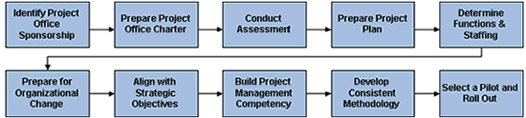
Figure 2: The Ten Steps of a Successful Strategic Project Office Launch

PMO Capabilities
The PMO is expected the have the following capabilities:
- Template Management enables the PMO to create, control and monitor templates to facilitate governance and adherence to project control standards;
- Opportunity Management enables the PMO to understand what new business is forthcoming and to plan for the work ahead of time;
- Request Management ensures that the PMO receives requests for work and resources in a consistent and easy-to-evaluate fashion;
- Resource Management enables the PMO to control resource allocation and utilization;
- Project-link and native project management capabilities help the PMO track project execution as well as issues and risks to ensure on-time and on-budget project delivery;
- Project Management ensures consistency and repeatability for all projects;
- Financial Management enables the PMO to easily track both revenue and costs;
- Document Management and approvals ensure that everyone is up-to-date with the most current information in accordance with security settings;
- Document approval workflow and document version control ensure adherence to business processes;
- Portfolio Management, Business Intelligence and Operational Reports ensure that the PMO receives all the data they need, while customizable dashboards display appropriate information to stakeholders;
- Easily manage a global organization with support for planning, scheduling and reporting across multiple, global work calendars;
- Easily connect Primavera with other enterprise systems using Web Services to ensure compliance with corporate standards;
- Security and administration makes it easy to coordinate and automate organizational changes, and
- Capacity Planning analysis that is based on real-world demand enables the PMO to see gaps and surpluses in the workforce.

Improving Organisational Performance
Project Office implementation is not simple. Success comes from accurately understanding the magnitude of the initiative, and from planning and working to that scale. It takes commitment on the part of the organization, and a skilled team of professionals to support the implementation and ongoing activities. Organizations that implement a Strategic Project Office can expect the following benefits as a result of their efforts:
- Increased profitability;
- Optimized portfolio of projects;
- Reduced project costs;
- Improved quality;
- Reduced lead time to market;
- Decreased scope changes;
- Minimized project risk;
- Quickened response to market opportunities;
- Improved alignment of projects to corporate strategies;
- Enhanced integration and resource management;
- Heightened team involvement in all project phases;
- Improved oversight of project activities enterprise-wide;
- Centralized expertise and consolidated activities;
- Improved communication of organizational vision and goals, and
- Elevated image of professionalism and predictability.

PM Assessment & Improvement Planning

Stage 1 – Project Maturity Assessment
Based on the PMMM framework, PM Solutions begins by assessing the many aspects of the organization to determine the organization's current project management maturity level. One then applies the PMMM as a guide in implementing project management improvement aligned with industry best practices.
Note: PM Solutions' PMMM mirrors the Software Engineering Institute Capability Maturity Model's (CMM®) five evolutionary maturity levels, and examines maturity development across nine knowledge areas in the Project Management Institute's (PMI®) A Guide to the Project Management Body of Knowledge (PMBOK® Guide 3rd Edition).
The appropriate target level of maturity varies for each organization based on specific goals, strategies, resource capabilities, scope, and needs determined during a comprehensive assessment. The assessment deliverables:
- Baseline your current environment and document issues through interviews, web surveys, and artefact reviews;
- Document, analyse, and present you with project management maturity assessment findings;
- Evaluate the cultural influences within your organization that affect change readiness, and
- Map your current situation to the Project Management Maturity Model in order to identify gaps and establish the goals for your organization .

Stage 2 – The Improvement Plan
Results from the Assessment are used to develop a clear, step-by-step path that charts the way to superior organizational performance and maturity. The improvement plan:
- Quantifies the business case for implementing project management improvement initiatives;
- Defines the recommended actions to become a more mature project organization;
- Identifies the scope, key deliverables, and measures for success for all improvement activities required to meet your organization's business goals;
- Includes a change enablement plan to address the cultural barriers within your organizational community;
- Provides realistic milestones for short-term process improvement activities, and
- Maps out a framework to achieve a sustainable project management culture across your enterprise.

Attachments

Attachment A - Project Management Maturity Model
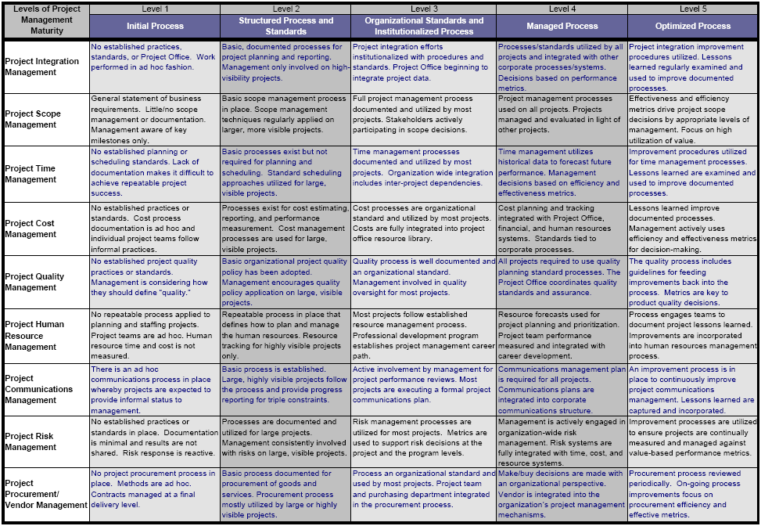

End Of Document

